**HDI Laboratory, UNMC**

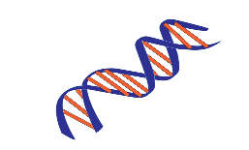

[This Photo](https://commons.wikimedia.org/wiki/File:DNA_small.svg) by Unknown Author is licensed under [CC BY-SA](https://creativecommons.org/licenses/by-sa/3.0/)

**Tissue Identification/ verification Testing**

**University of Nebraska Medical Center**

**Jesse Cox; ECI 6004**

**601 South Saddlecreek Road**

**Omaha, NE 68106**

|  |  |
| --- | --- |
| **RESULTS CONTACT** | **INVOICE/BILLING CONTACT** |
| **Name of requestor:** | **Name:** |
| **Address to send report:** | **Address:** |
| **Phone number:** | **Phone Number:** |
| **Email:** | **Email:** |

**Instructions regarding testing/ comparisons:**

**Questioned Samples:**

|  |  |  |
| --- | --- | --- |
| **Sample Name** | **Tissue/Source** | **Preserve or Consume sample?** |
|  |  |  |
|  |  |  |
|  |  |  |
|  |  |  |

**Known/ Reference Samples:**

|  |  |  |
| --- | --- | --- |
| **Sample Name** | **Tissue/Source** | **Preserve or Consume sample?** |
|  |  |  |
|  |  |  |
|  |  |  |
|  |  |  |

**If you have any questions, please contact the lab at (402) 559-7220. Thank you!**