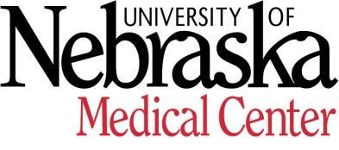

NEBRASKA S HEALTH SCIENCE CENTER COLLEGE OF NURSING
A Partner with Nebraska Health System

By April 15, faculty members will notify the Promotion and Tenure committee chairman in writing the intent to apply for promotion and/or tenure and your areas of accomplishment by level in the year prior to when action regarding promotion or tenure will be deliberated. This should have been discussed with your supervisor and acknowledged on this form prior to submission. Please specify:
Rank you are seeking ____________________________
Please specify the two primary areas of accomplishments you are seeking promotion for:
______ Teaching and Scholarly Activity
______ Scholarly Activity and Professional Service
______ Teaching and Professional Service

I have discussed this with my department chair/supervisor

__________________________ Signature of Assistant Dean/Supervisor

__________________________ Date

985330 Nebraska Medical Center / Omaha, NE 68198-5330 / FAX: 402-559-4303 / www.unmc.edu

