Document Version date: 10/20/2023
Note: As the IRB of record allows, the consent form should appear on the appropriate letterhead for easy identification as a research consent form. The logos included will be one of the following (placed in the upper left-hand corner of the header):
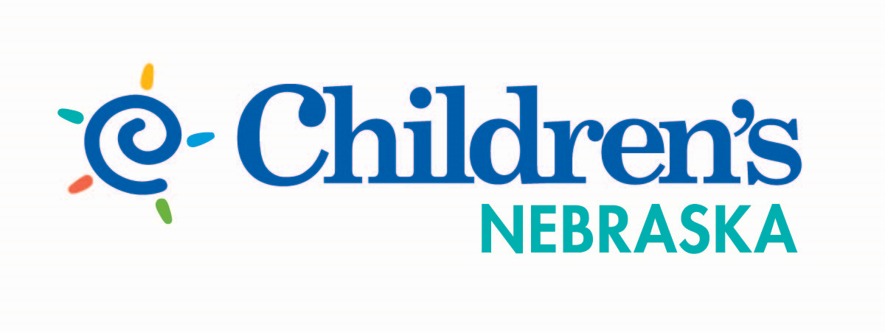

The UNMC IRB number should appear in the consent. When using combined consent documents, pronouns may be modified as appropriate (e.g., “you” may be modified to “your child”).

Contraception/Pregnancy Risk Language for FDA regulated research
Insert appropriate contraception language based on FDA Pregnancy and Lactation Labeling Rule and/or FDA Use-In-Pregnancy category, as per HRPP Policy 3.9 (Contraception Requirements)

Category A and Some Category B Drugs (do not require contraception)
It is possible that the medicines used in this study could injure a fetus if you or your partner becomes pregnant while taking them. You have already been told what is known about this possibility, and you are encouraged to ask further questions.

Category B, C and D Drugs
It is possible that the medicines used in this study could injure a fetus if you or your partner becomes pregnant while taking them. You have already been told what is known about this possibility, and you are encouraged to ask further questions.

You may want to discuss this with others before you agree to take part in this study. If you wish, we will arrange for a doctor, nurse, or counselor who is not part of this study to discuss the potential risks and benefits with you and anyone else you want to have present.

Because of the potential risks, you or your partner must not become pregnant while participating in this study. Women must have a negative pregnancy test before entering the study [and before each treatment as appropriate].

If you are sexually active and can get pregnant, or can get your partner pregnant, you must use ONE [or TWO] appropriate method of birth control every time you have sex, or you must not have sex.

You can get additional information about methods to avoid pregnancy by calling the UNMC Research Subject Advocate's Office at (402) 559-6941.

You will need to continue to avoid pregnancy for X months after finishing the research.
By signing this and being in the study, you are agreeing to not get pregnant while you are on the study and for X months after. Should you become pregnant while on this study, you should immediately notify the study personnel. The investigator will assist you in finding appropriate medical care. The investigator also may ask to be allowed to continue getting information about your pregnancy. You can refuse to provide this information.

Category X drugs
If required, the following statement may be appended to the required FDA language:
The [name of institution] does not promote or condone the use of contraception.

If there are risks always end with this statement:
You could have other side effects that we do not know about yet.

The consent form should indicate how frequently pregnancy testing will be performed, how often subjects will be informed of results, and whether subjects will be removed from the study if they become pregnant. If the study involves minors, the consent form must disclose that the results of the pregnancy testing will be shared with the parents. For more information, please see UNMC HRPP policy 3.10 Pregnancy Testing.

Costs to Subject (required for all clinical trials):
You will have to pay any insurance deductibles and co-payments. If you want to speak with someone about your insurance, just tell us.

Payment: If SSN is required for payment, then use the following standard statement:
In order to pay you, you will have to provide your social security number. You can choose not to provide this and still participate in the research but we will be unable to pay you.

If this study has a tissue bank include this standard statement:
We do not plan to pay you if any new drugs or products are made using the sample(s) you donated. It is our policy that all donated samples belong to the organization.

Subject Injury Language for greater than minimal risk research
Add following to consent form subject injury language:
Your health and safety is our main concern. If you are injured or have a medical problem because of this study call someone listed at the end of this consent form. You can get emergency medical treatment at Nebraska Medicine. You can also go to your doctor, the nearest emergency room or call 9-1-1.
[Insert the commercial sponsor language]
We have no plans to pay for your treatment or give you any other money or compensation.
Signing this does not mean you have given up any of your legal rights.

HIPAA Language
We also will get medical information about you (like medical record number, medical history, or the results of physical exams, blood tests, x-rays or other medical or research procedures). We call this "protected health information" or PHI. PHI is protected by a law called the HIPAA Privacy Rule. We will collect the smallest amount of PHI that we can. We will keep your PHI as confidential as possible.

By signing this consent form, you are letting us (the researchers listed on this consent form and other people involved in this research at the Organization) have access to your PHI. Your PHI will be used only for the purposes described in the section "What is the reason for doing this research study?"

You can change your mind and tell us to stop collecting your PHI for use in this research at any time by writing to the principal investigator. We can still use the PHI we have already collected. If you tell us to stop collecting your PHI, you will have to stop being in this research.

We may share your PHI with other groups listed below:
- The UNMC Institutional Review Board (IRB)
- Institutional officials designated by the UNMC IRB
- The HHS Office for Human Research Protections (OHRP)

We may share your PHI with other groups listed below. The HIPAA Privacy Rule requires these groups to protect your PHI.
- The Food and Drug Administration (FDA) [if study involves FDA regulated drug, device, or biologic]
- National Institutes of Health (NIH) [if study is funded by the NIH]
- Researchers at [insert the name of the institution(s) involved in the study if this is a multi-institution study where PHI will be shared with other researchers]
- Your health insurance company [if the Institution expects third party payers to pay for clinical procedures performed during the course of the research]
- The Fred & Pamela Buffett Cancer Center Scientific Review Committee (SRC) [if the research involves patients with cancer]

We may share your PHI with other groups listed below. These groups are NOT required by HIPAA to protect your PHI. If we share your PHI with these other groups they may share it with others who also do not have to protect it under HIPAA.
- [insert name of sponsor], which sponsors this research and may pay the Organization to do this research
- [insert name of CRO] which has been hired by the sponsor to help run the research
- The Data and Safety Monitoring Committee (DSMC)
- [insert name of NCI National Cooperative Group, if applicable]
- The National Cancer Institute's (NCI) Clinical Trial Reporting Program

In addition, choose one of the statements that appropriately represents your study:

You are letting us use and share your PHI for as long as the research is going on.
Or:
You are letting us use and share your PHI for as long as the sponsor needs so it can get approval from the FDA.
Or:
There is currently no plan to end this study. You are letting us use and share your PHI for as long as we want.

Note: Information related to subject rights should include the UNMC IRB and Research Subject Advocate contact information.

What are your rights as a research participant?
You have rights as a research subject. These rights have been explained in this consent form and in The Rights of Research Subjects that you have been given. If you have any questions concerning your rights, or want to discuss problems, concerns, obtain information or offer input, or make a complaint about the research, you can contact any of the following:

The investigator or other study personnel
- Institutional Review Board (IRB)
  - Telephone: (402) 559-6463
  - Email: IRBORA@unmc.edu
  - Mail: UNMC Institutional Review Board, 987830 Nebraska Medical Center, Omaha, NE 68198-7830
- Research Subject Advocate
  - Telephone: (402) 559-6941
  - Email: unmcrsa@unmc.edu

