CHEMICAL WASTE  When printing labels, use Avery Label 5163.  Chemical(s)/Percentage (must equal 100%):  ____________________________________________________________________________________________________________________________________  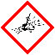  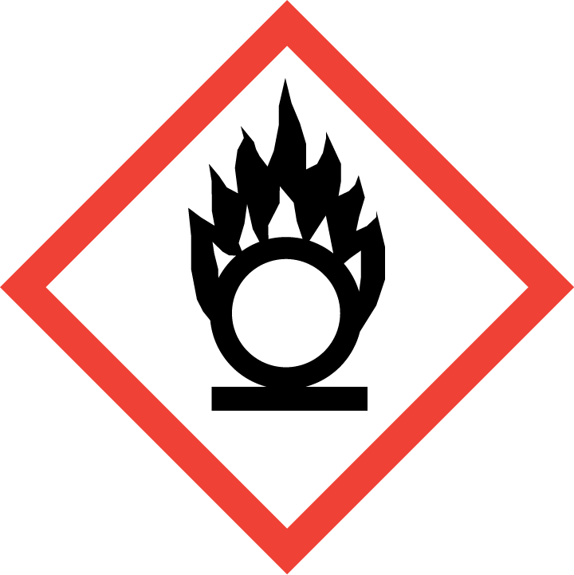  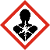  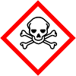  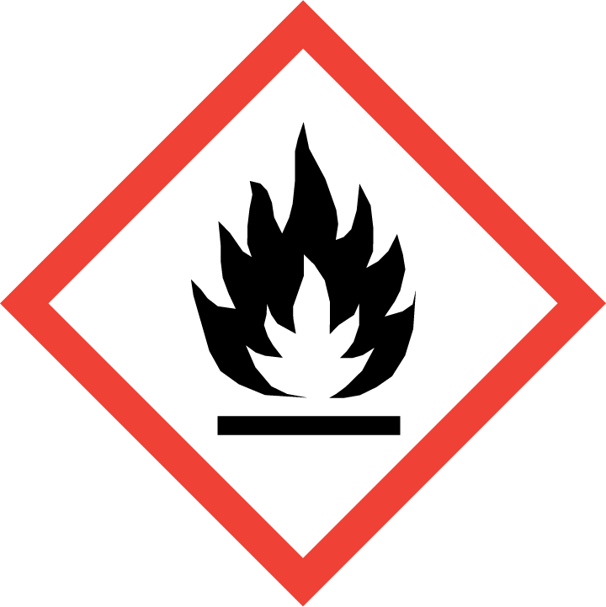  Hazards(mark all that apply):  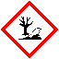  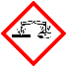  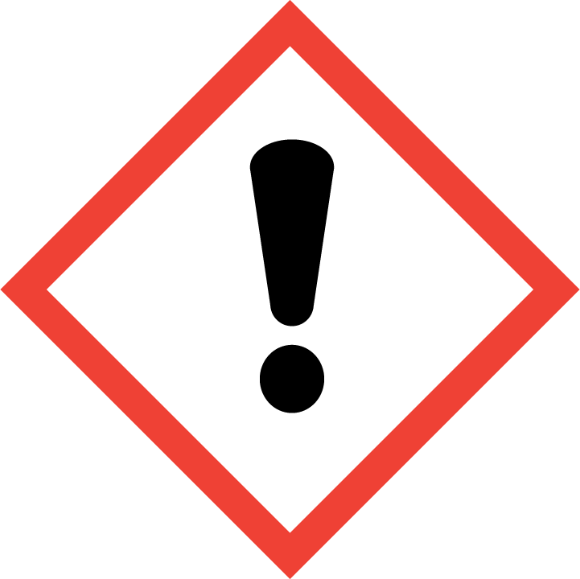  Other (please specify)  _______________________ |  | CHEMICAL WASTE  Chemical(s)/Percentage (must equal 100%):  ____________________________________________________________________________________________________________________________________  Hazards(mark all that apply):  Other (please specify)  _______________________
CHEMICAL WASTE  Chemical(s)/Percentage (must equal 100%):  ____________________________________________________________________________________________________________________________________  Hazards(mark all that apply):  Other (please specify)  _______________________ |  | CHEMICAL WASTE  Chemical(s)/Percentage (must equal 100%):  ____________________________________________________________________________________________________________________________________  Hazards(mark all that apply):  Other (please specify)  _______________________
CHEMICAL WASTE  Chemical(s)/Percentage (must equal 100%):  ____________________________________________________________________________________________________________________________________  Hazards(mark all that apply):  Other (please specify)  _______________________ |  | CHEMICAL WASTE  Chemical(s)/Percentage (must equal 100%):  ____________________________________________________________________________________________________________________________________  Hazards(mark all that apply):  Other (please specify)  _______________________
CHEMICAL WASTE  Chemical(s)/Percentage (must equal 100%):  ____________________________________________________________________________________________________________________________________  Hazards(mark all that apply):  Other (please specify)  _______________________ |  | CHEMICAL WASTE  Chemical(s)/Percentage (must equal 100%):  ____________________________________________________________________________________________________________________________________  Hazards(mark all that apply):  Other (please specify)  _______________________
CHEMICAL WASTE  Chemical(s)/Percentage (must equal 100%):  ____________________________________________________________________________________________________________________________________  Hazards(mark all that apply):  Other (please specify)  _______________________ |  | CHEMICAL WASTE  Chemical(s)/Percentage (must equal 100%):  ____________________________________________________________________________________________________________________________________  Hazards(mark all that apply):  Other (please specify)  _______________________

