Chemical(s)/Percentage (must equal 100%):  When printing labels, use Avery Label 5163.  ____________________________________________________________________________________________________________________________________  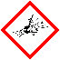  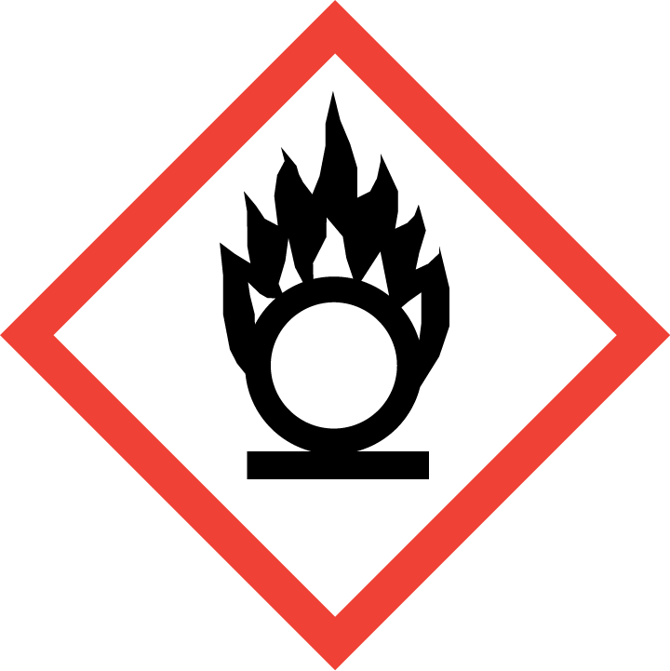  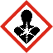  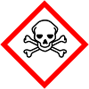  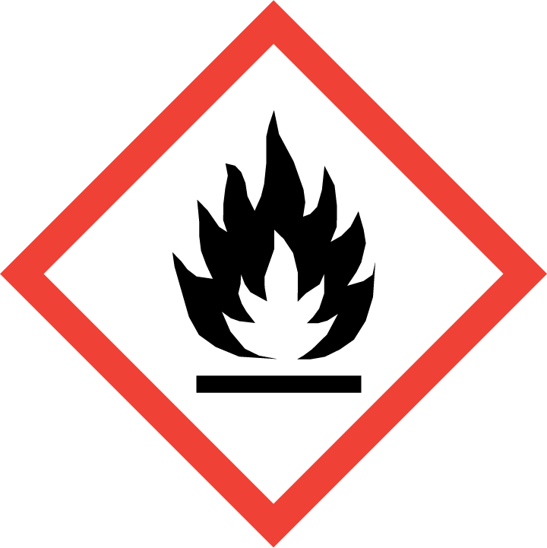  Hazards(mark all that apply):  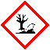  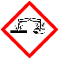  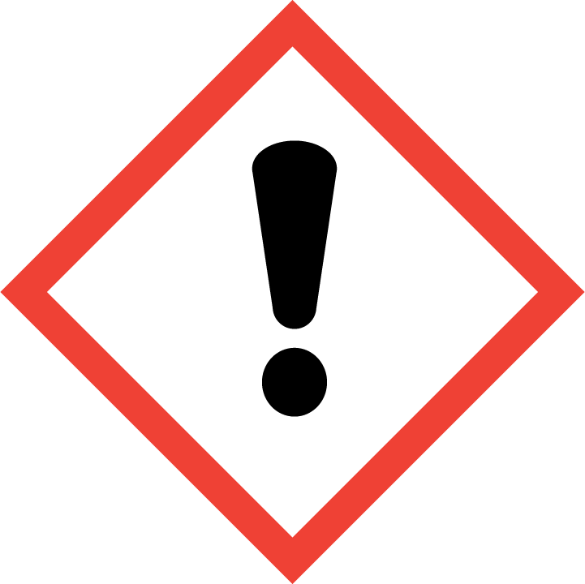  Other (please specify)  _______________________ |  | Chemical(s)/Percentage (must equal 100%):  ____________________________________________________________________________________________________________________________________  Hazards(mark all that apply):  Other (please specify)  _______________________
Chemical(s)/Percentage (must equal 100%):  ____________________________________________________________________________________________________________________________________  Hazards(mark all that apply):  Other (please specify)  _______________________ |  | Chemical(s)/Percentage (must equal 100%):  ____________________________________________________________________________________________________________________________________  Hazards(mark all that apply):  Other (please specify)  _______________________
Chemical(s)/Percentage (must equal 100%):  ____________________________________________________________________________________________________________________________________  Hazards(mark all that apply):  Other (please specify)  _______________________ |  | Chemical(s)/Percentage (must equal 100%):  ____________________________________________________________________________________________________________________________________  Hazards(mark all that apply):  Other (please specify)  _______________________
Chemical(s)/Percentage (must equal 100%):  ____________________________________________________________________________________________________________________________________  Hazards(mark all that apply):  Other (please specify)  _______________________ |  | Chemical(s)/Percentage (must equal 100%):  ____________________________________________________________________________________________________________________________________  Hazards(mark all that apply):  Other (please specify)  _______________________
Chemical(s)/Percentage (must equal 100%):  ____________________________________________________________________________________________________________________________________  Hazards(mark all that apply):  Other (please specify)  _______________________ |  | Chemical(s)/Percentage (must equal 100%):  ____________________________________________________________________________________________________________________________________  Hazards(mark all that apply):  Other (please specify)  _______________________

